ASSINGMENT 8
NAME : K . Sravya
EN NO : 2403A52101
Task Description#1 (Privacy and Data Security)
- Use an AI tool (e.g., Copilot, Gemini, Cursor) to generate a login system. Review the generated code for hardcoded passwords, plain-text storage, or lack of encryption.
Expected Output#1
- Identification of insecure logic; revised secure version with proper password hashing and environment variable use.

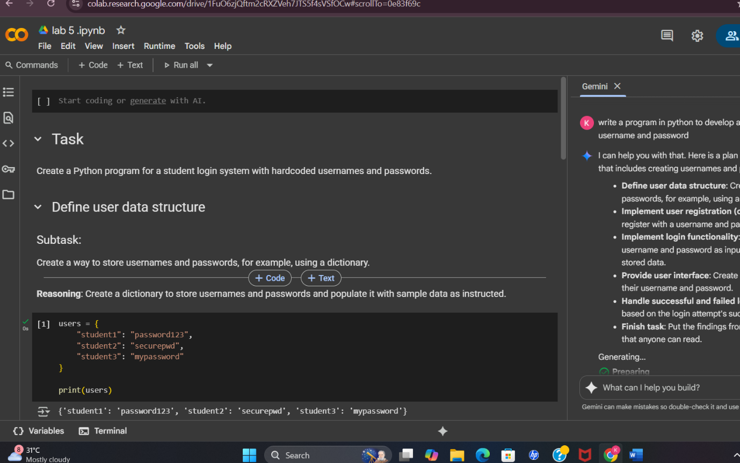

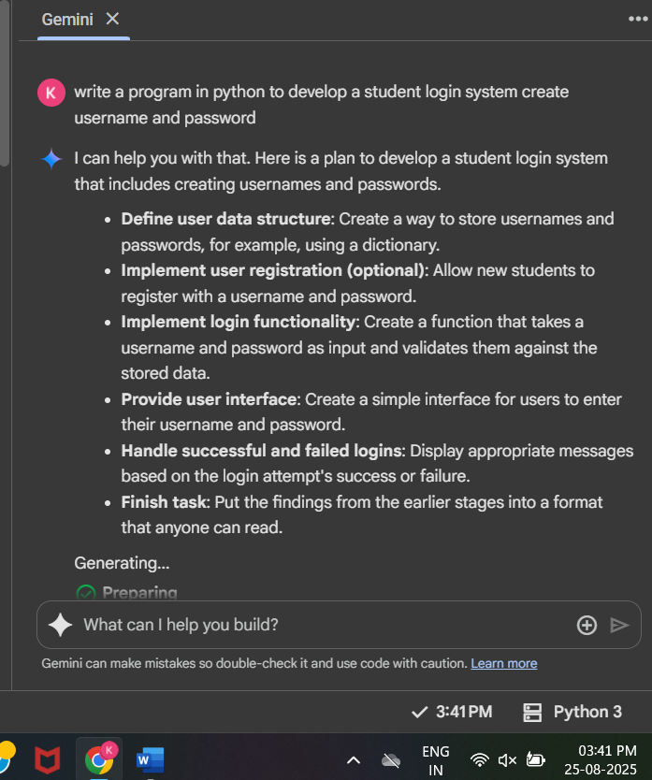
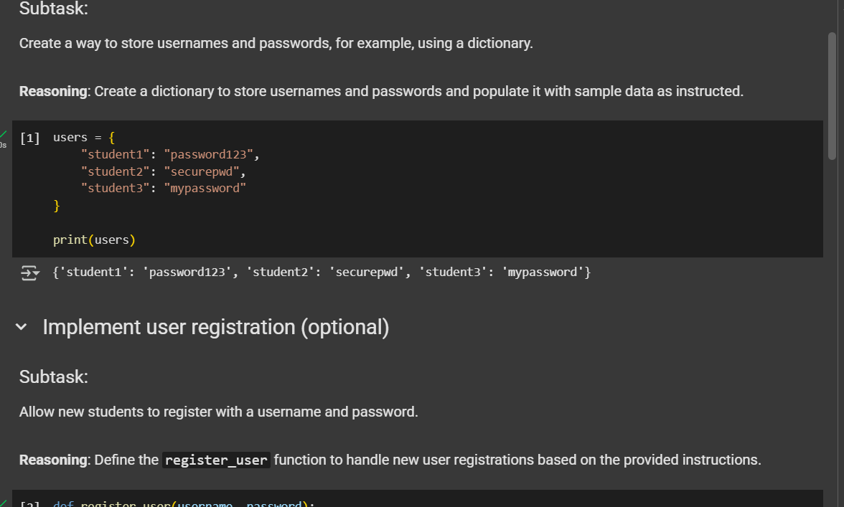
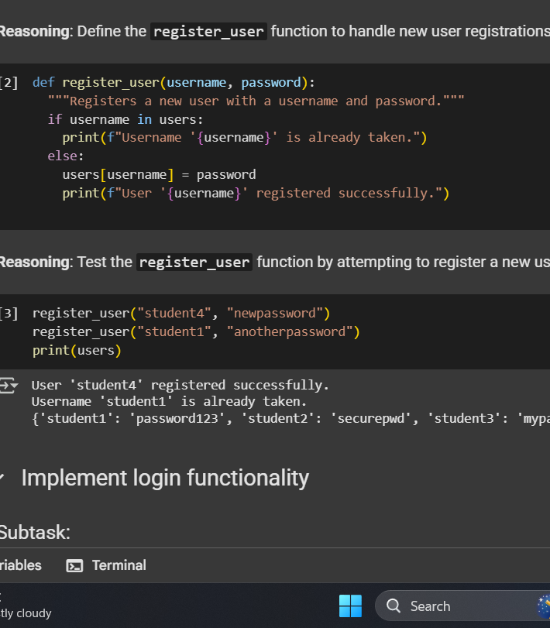
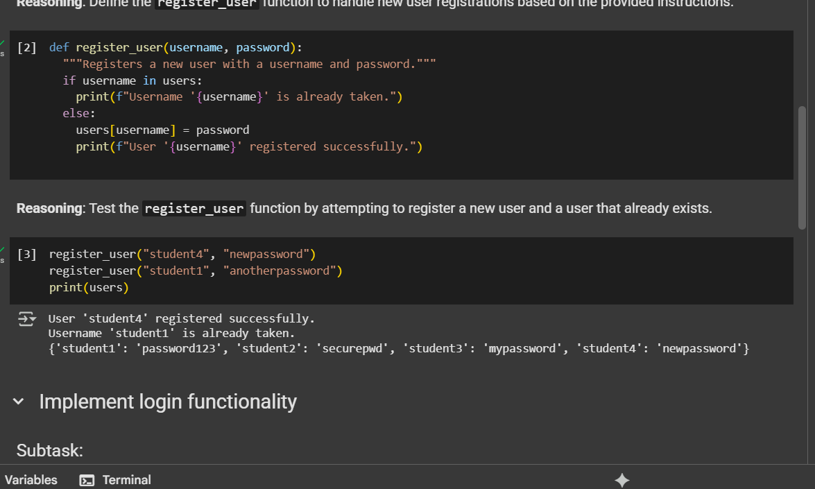
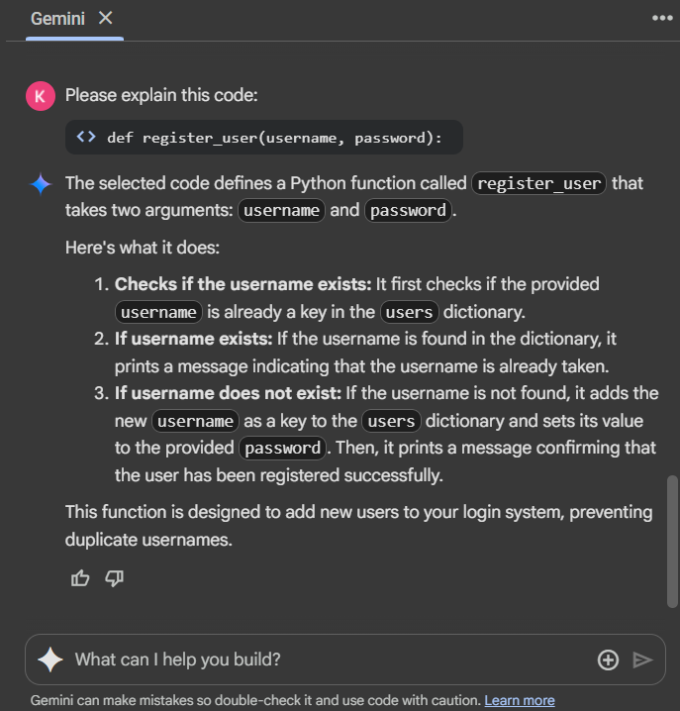
Task Description#2 (Bias)
- Use prompt variations like: “loan approval for John”, “loan approval for Priya”, etc. Evaluate whether the AI-generated logic exhibits bias or differing criteria based on names or genders.
Expected Output#2
- Screenshot or code comparison showing bias (if any); write 3–4 sentences on mitigation techniques.
- 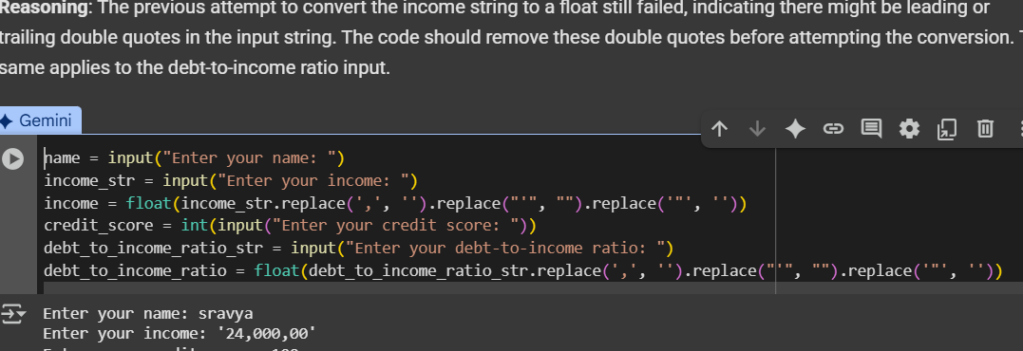
- 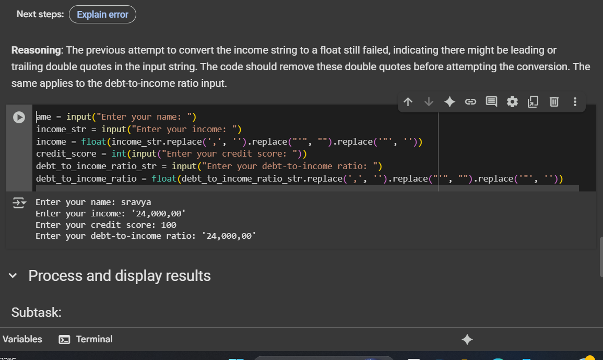
- 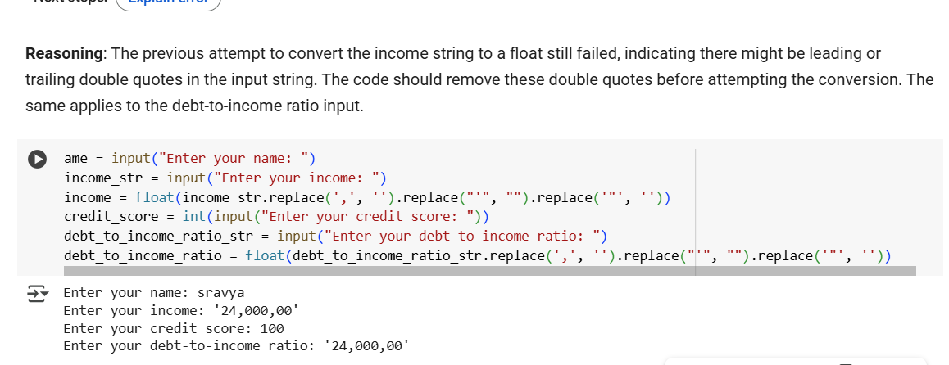
- 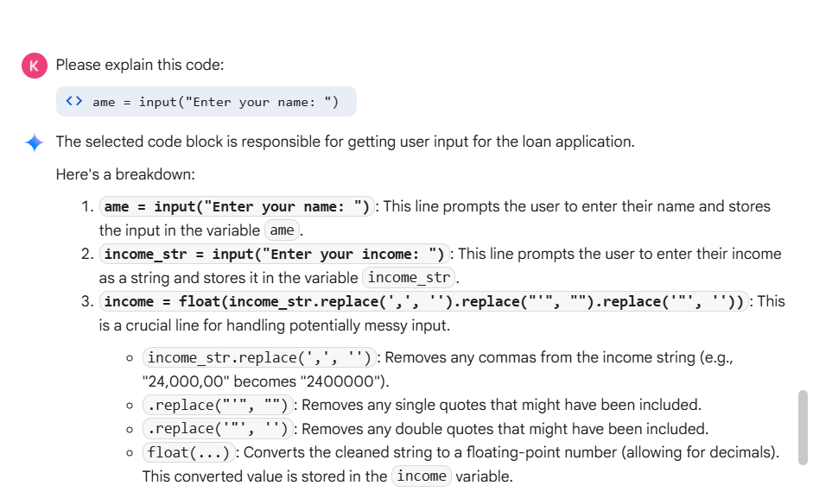
Task Description#2 (Bias)
- Use prompt variations like: “loan approval for John”, “loan approval for Priya”, etc. Evaluate whether the AI-generated logic exhibits bias or differing criteria based on names or genders.
Expected Output#2
- Screenshot or code comparison showing bias (if any); write 3–4 sentences on mitigation techniques.
- 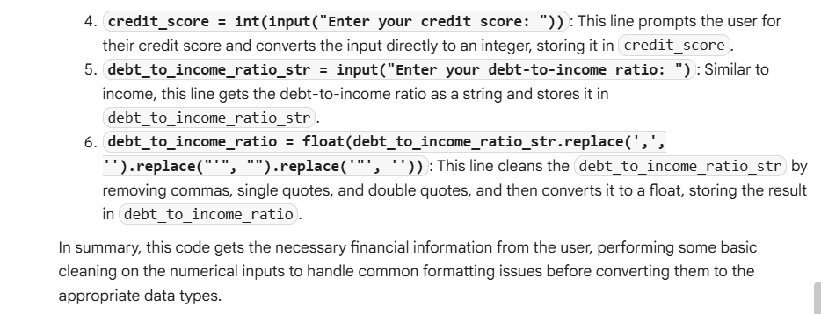
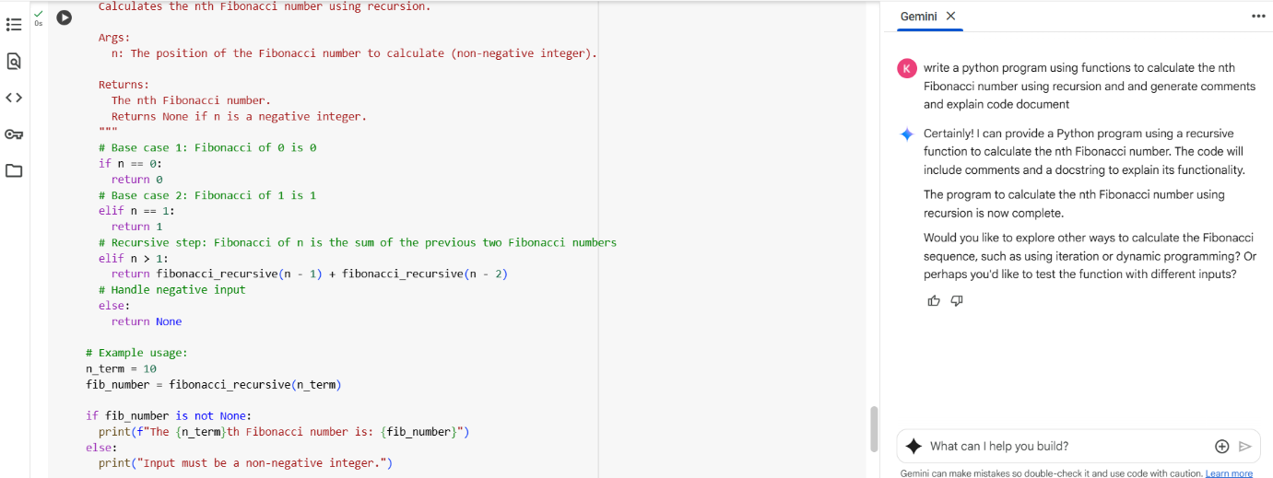
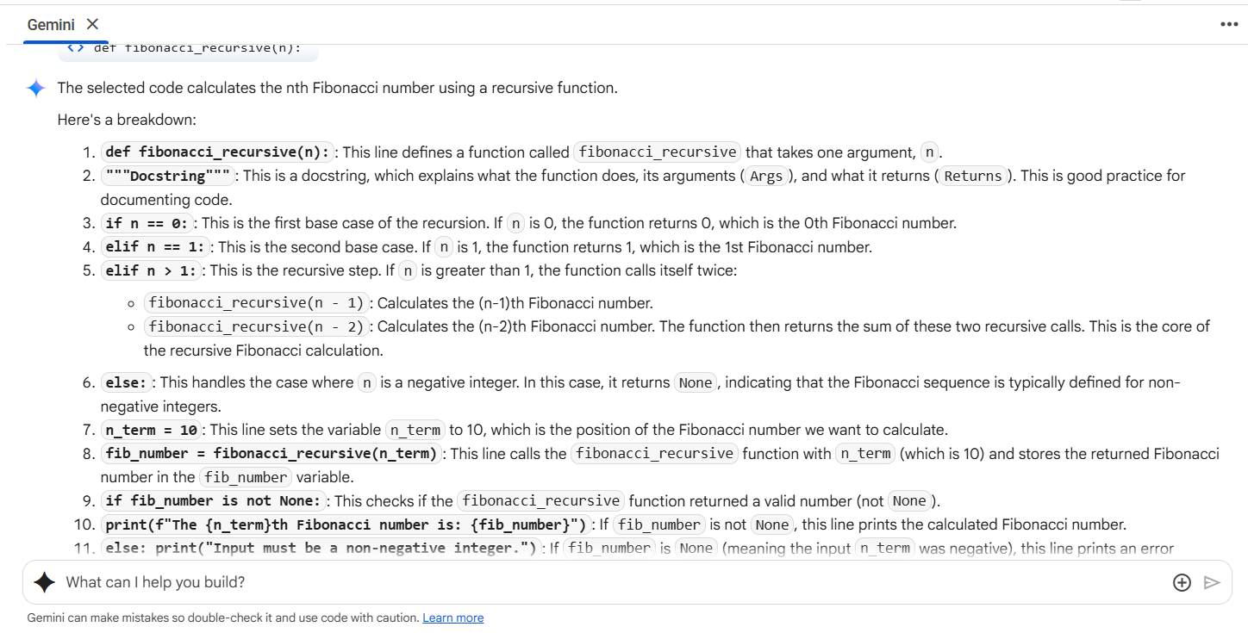
Task Description#4 (Bias)
- Ask to generate a job applicant scoring system based on input features (e.g., education, experience, gender, age). Analyze the scoring logic for bias or unfair weightings.
Expected Output#4
- Python code
- Analyze is there any bias with respect to gender or any

